**A Discussion regarding the relationship among Fourier Series, Fourier Transform, Discrete Time Fourier Transform and Discrete Fourier Transform and Z-Transform**

Saqr Thabet

University of Electronic Science and Technology of China

Chengdu – Sichuan - China

List of the content:

1. Introduction.
2. Fourier Series.
3. Continuous Time Fourier Transform.
4. Discrete Time Fourier Transform.
5. Discrete Fourier Transform.
6. Z-Transform.
7. Conclusion



Prepared by :

Student Name : Saqr Khalil Saeed Thabet

School : Communication and Information Engineering

Student No : 201424020114

Under the supervision of Prof. Jingran lin

**Introduction**

Signals analysis is considered to be a major subject to study in our meantime because signals are playing a substantial role in all our technological applications. Furthermore signal mathematical presentation it has been for centuries and still till now a challenging matter, it is not easy to interpret and investigate signals and their behavior till it appropriately transformed. Needless to say, Transforms are a very handy to explain and facilitate our standing and our comprehension towards all the phenomena includes and involved signals; For instance, Fourier Transform is a fundamental tool to translate the signal from the time-domain prospective to the frequency-domain prospective. Nevertheless, frequency-domain is not enough to expose all the characteristics related to the signal, starting from that point signals are also transformed and analyzed through the Z-plane too, the differences between the Fourier Transform and Z-transform are considered to be a sign of diversity and a matter of observing the same phenomenon from different angles.

**Definition :**

**The Fourier series**, represent the signal by their harmonic components or set of coefficients {}.begin with DC or constant component ,then the first harmonic or in other words the fundamental frequency, then Second harmonic, which is a components of twice the frequency ,etc. Each component has an amplitude in the Frequency domain, regarding to its contribution to the total function or signal.

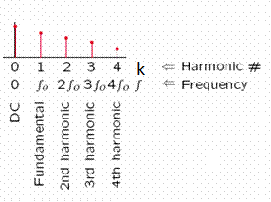

 in terms of complex exponential synthesis equation

 in terms of trigonometric

 , is the Fourier series coefficient analysis equation

The sequence () can be regarded as a function of (k) and is called Fourier spectrum of x(t).

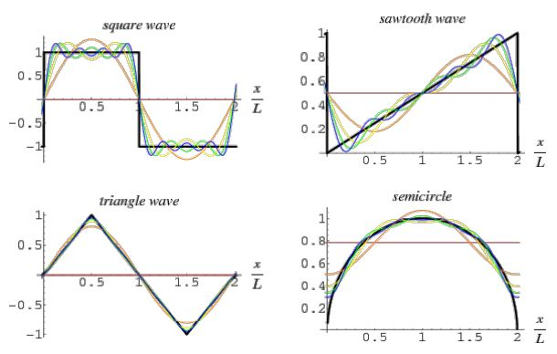In some cases of the periodic signals the coefficients may have an infinite value ,consequently the integration diverge. Fortunately, no Convergence difficulties for large classes of periodic signals and signals with finite number of discontinuities too.

the Fourier series representation equals the signal everywhere except at the isolated points of discontinuity at which the series converges to the average value of the signal on either side of the discontinuity in this case the difference between the original signal and its Fourier series representation contains no Energy and consequently the two signals can be thought of as being the same for all practical purpose ,as it is presented in Gibbs phenomenon.

In FOURIER SERIES:

1. **Periodic** function , converts into a Discrete linear combination of complex exponential or sin & cos functions have amplitudes of , which occurs at a discrete set of harmonically related frequencies

2. **Non Periodic** function, NOT APPLICABLE

In FOURIER TRANSFORM:

1. **Periodic** function, converts its Fourier series into the frequency domain.

2. **Non Periodic** function, converts into Continuous frequency domain as

for the aperiodic signals the complex exponentials occurs at a continuum of frequencies .

An aperiodic signal can be represented as linear combination of complex exponentials, which are infinitesimally close in frequency. So the representation take the form of an integral rather than a sum , Aperiodic signal can be viewed as a periodic signal with an infinite period. In other words, The representation of aperiodic signals not as weighted sums of harmonically related sinusoid but as weighted integrals of sinusoids that are not all harmonically related sinusoids, which is an extension from Fourier series to Fourier integral or Transform.

Generally, Transforms are used because the Time-domain mathematical models of systems are generally complex differential equations. Transforming these complex differential equations into simpler algebraic expressions makes them much easier to solve. Once the solution to the algebraic expression is found, the inverse transform will give you the time-domain response.

**Definition:**

**The Fourier transform,** represents a generalization of Fourier series. Recall that the Fourier series. 

We can think of () as a function of (k) ,and get a set of infinitely many equally spaced points , in this case we think of ()as a function of (k), the Wave Number.

We can also think of () as a function of (), the Frequency, If (T) is large, then  is small, so for large T, we can think of ( () ) being a continuous function, as the samples becomes more and more finely spaced.

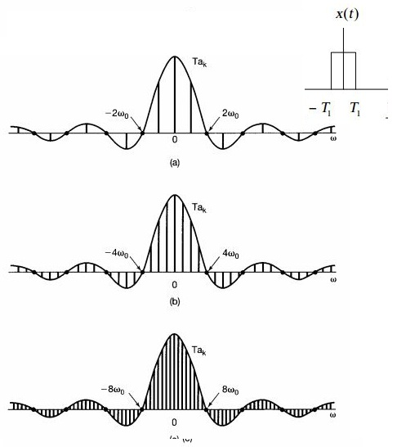

the Fourier series coefficients and their envelope function for the periodic square wave x(t), for several values of T, (a)T=4 ,(b)T=8,(c)T=16 that suggest the following:

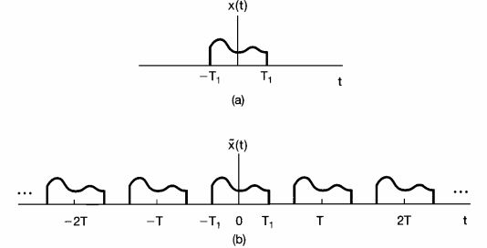

We can think of aperiodic signal x(t) as a limit of a periodic signal  as the period becomes arbitrary large ,and we examine the limiting behavior of the Fourier series representation for this signal ,in particular consider a signal x(t) with finite duration that is for some number  , x(t)=0 if  > T , as it is illustrated above, from this aperiodic signal we can construct a periodic signal  for which x(t) is one period. And as it shown above, we choose the period of T to be larger,  is indicated to x(t) over a larger interval and as  , is equal to x(t) for any finite value of t,

 ,  and since 

 

And after defining the envelope,  of ,

 analysis equation

 synthesis equation

**Definition :**

**The Continuous Time Fourier Transform (CTFT),**is a tool that breaks a waveform (a function or signal) into an alternate representation, characterized by sine and cosines. which consequently an expression in terms of the [amplitude](http://en.wikipedia.org/wiki/Amplitude) (and [phase](http://en.wikipedia.org/wiki/Phase_offset)) of each of the [frequencies](http://en.wikipedia.org/wiki/Frequency) that make it up. The resulting function, a ([complex](http://en.wikipedia.org/wiki/Complex_number)) amplitude that depends on frequency, is called the frequency domain representation of the function. In other point of view, The F.T can be understood as an integral operator meaning that it is deﬁned via an integral and that it maps one function to the other, regarding the same case, the Laplace transform is another integral operator. Not to mention that, the term Fourier Transform refers both to the operation that associates to a function its frequency domain representation, and to the frequency domain representation itself.

**Definition :**

The frequency domain representation of a discrete time sequence x[n] is **the Discrete Time Fourier transform (DTFT),** by which a time domain sequence is mapped into a continuous function of the frequency variable (ω), because the of the periodicity of the DTFT the corresponding discrete time sequence x[n] can be simply obtained by computing its Fourier series representation.





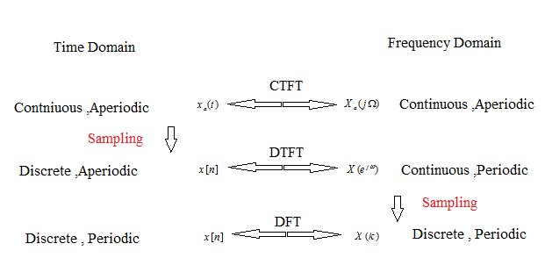Basically, **CTFT** is for signals which are aperiodic and continuous in time domain. It's aperiodic and Continuous in frequency domain. On the other hand, **C.T Fourier Series** is for signals which are periodic and continuous in time domain. It's discrete and aperiodic in frequency domain.   
**DTFT** is for signals which are aperiodic and discrete in time domain. It's periodic and continuous in frequency domain. In the same manner, **D.T Fourier Series** is for signals which are periodic and Discrete in time domain. It's periodic and discrete in frequency domain.   
*The basic rule of thumb is, if a signal is discrete in one domain ( T or F), it's periodic in the other domain.  (F or T), and If it's continuous in one domain, it is aperiodic in other domain.*  
As a matter of fact, no naturally occurring signals in this universe last forever. So CTFS and DTFS are purely mathematical tools. It helps our understanding.   
If you notice, CTFS and DTFT are the dual of each other.   
Regarding the convergence of the Fourier Transform, some conditions were introduced to guarantee that signal (Periodic or Aperiodic) has a F.T:

-x(t) is Absolutely integrable : . CTFT

-x(t) is absolutely summable: DTFT

-x(t) is square summable 

However, some periodic signals can be presented in F.T even if they don’t converge, using impulse function. Those conditions turned out to be sufficient conditions.

To apply Fourier Transform analysis on Real world analog signal, the problem we are expecting to face is with real world analog signals as they require infinite memory, How to solve that ? The Discrete Fourier Transform (D.F.T) was introduced.

Transforms are rational functions and are thus more convenient to deal with finite-length sequences rather than the infinite-length sequence in the time domain.

**Definition:**

**Discrete Fourier Transform (DFT),** can be understood as a numerical approximation to the Fourier transform. This is used in the case where both the time and the frequency variables are discrete. Moreover**,** DFT can be seen as the sampled version (in frequency-domain) of the DTFT output. It's used to calculate the frequency spectrum of a discrete-time signal with a computer, because computers can only handle a finite number of values.

And because “the Sampling frequency in one domain (frequency-Time-Space) is determined by the signal length in the other domain” and as x[n] comes with finite-length (N) or it might be explained as our range of vision, so we need (N) independent piece of information, so  is the sampling frequency.(k) is the sequence of the samples , by applying all of that on DTFT:

= ,k=0,1,2,,,,N-1



 , 0 < k < N-1



So DFT is strictly a tool to do Fourier analysis on CTFT or DTFT.

However, sampling means we have fundamentally altered the signal from continuous to discrete and it means we have changed from something that looks like CTFT in both domains to DTFT. The frequency domain will look periodic now but it doesn't matter as we have sampled at a high enough rate.

The difficulty of Fourier Transform that there are signals for which the Fourier Transform don’t exist and for those signals, what we do instead of , we also introduce a convergence factor , so that the resulting signal () converges so the Fourier Transform shall exist for appropriate choosing value of .

In Fourier Transform, we were just looking in one track mind (imaginary domain”” of Z-plane) but using Z-transform we are covering the complete Z-Plane both (Imaginary & Real domain).

In DFT we are working under the assumption, that we are computing in a complex plane, but we are confining our self to a unity circle with radius =1, if we remove this restriction to go further in the general Z-plane.

Both DFT and Z-transform work for Discrete signal.

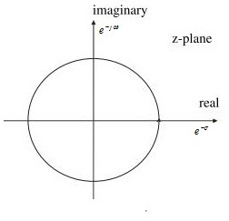

**Definition:**

**Z-transform** is the general case of DFT, when we consider unit circle then, Z-transform becomes Discrete Fourier Transform (DFT)".

In Fourier Transform, in case of non convergence signals x(n), we assign to the x(n) in consequence at the Z-plane :

-The convergence occurs at a Unity Circle of Radius =1.

- is the only variable in the equation.

In Z-transform the same interpretation is conducted with small change, in case of non converging signals x(n) ,we assign  to the x(n) in consequence at Z-plane :

-The convergence occurs outside the highest pole circle.

- & are two variables in the equation.

 =  = 

(z) is a continuous complex variable has a magnitude  and angle 

 , the convergence factor introduced is 

The convergence sufficient conditions are either:

- Absolute summable 

- Square Summable 

However, those condition are not necessary insufficient conditions, this also complicates the matter because in Fourier Transform we were considering one track (just a circle of Radius =1), Now we are expanding to a total Z domain, total complex frequency domain so the question of existence shall be considered in Terms of Region Of Convergence (R.O.C).

So if the sequence does not converge in any place in R.O.C we say the

Z-transform doesn’t exist.

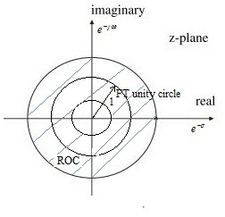

If ROC of Z-transform includes the unity circle then the Fourier Transform shall also exist, as the ROC is the region where the Z-transform exist, but if the Fourier Transform exist it doesn’t mean that Z-transform must exist too.

The z-transform equation is closely related to that for the [DFT](http://www.ling.upenn.edu/courses/ling525/fourier_family.html#DTFS). There's a crucial practical difference, in that we literally perform Discrete Fourier Transforms on concrete input vectors to produce concrete output vectors. We can't do that with the z transform, since (given a sampled impulse response) it defines a function on all points in the complex plane, so that both inputs and outputs are drawn from continuously infinite sets the z transform has an enormous, though indirect, practical value. As we can use it to perform a valuable analysis of an arbitrary linear constant-coefficient difference equation, deriving an expression for the z transform of the system's impulse response which we can use to calculate the system's "poles" and "zeros" in the frequency domain.

In different point of view, **Z-transform** is a digital equivalent of **Laplace transform** and it is used for steady state analysis of signals/systems, while **DFT** is digital analog of **Fourier transform**,

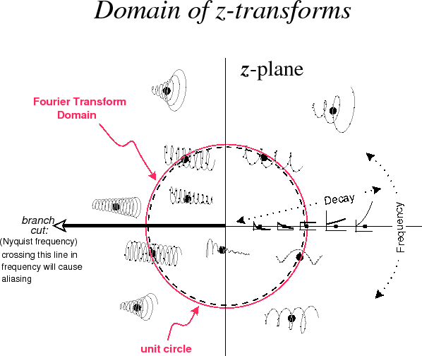

The Figure describes Sampled [generalized complex sinusoids](http://www.dsprelated.com/dspbooks/mdft/Generalized_Complex_Sinusoids.html) represented by points in the $ z$ plane.

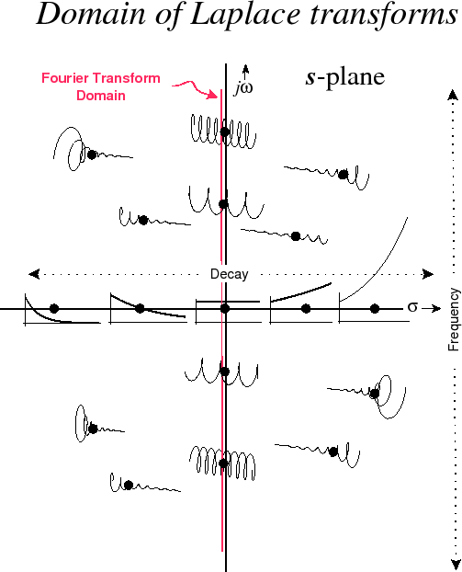**Fourier** is a subset of **Laplace**. Laplace is a more generalized transform.   
 The Figure depicts Generalized complex [sinusoids](http://www.dsprelated.com/dspbooks/mdft/Sinusoids.html) represented by points in the $ s$ plane.

Fourier Transform is used primarily for steady state signal analysis. While, Laplace is used for transient signal analysis. Laplace is good at looking for the Response to pulses, Step functions, Delta functions, while Fourier is good for Continuous signals. 

Actually, the Z Transform is not really a proper transform, just a re-interpretation of the sequence of samples as coefficients of a formal Laurent series.

In some cases the formal Laurent series converges, if it does, it does so on an annular region in the complex plane. For useful signals (stable, summable, exponentially decaying) this annulus contains the unit circle, and the evaluation of the Laurent series on the unit circle corresponds to the Fourier series.

The interesting point of connecting a signal sequence to a periodic function on the unit circle is the inverse transformation, that many useful sequences are sequences of Fourier coefficients. And of course that convolution of signals corresponds to point-wise multiplication of the functions.

In Conclusion,

Our standing towards all the phenomena related to signals had brought us a lot of benefits besides broaden our knowledge and promote our comprehension further ahead. It had allow us to utilize and exploit this subject to serve our needs either to transmit, receive transform, modify, manipulate, alter, cipher , control and maintain signals in many forms and under different aspects .